Task-1

Directory

# Text Description automatically generatedCheckout, echo, init, add :

Commit -m ,branch -M , remote add origin :

Config –global, status, add, commit -a :

Fetch, clone, merge, reset, rebase :

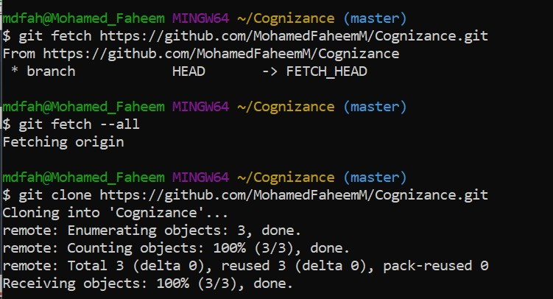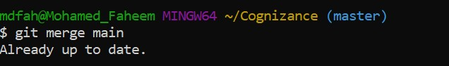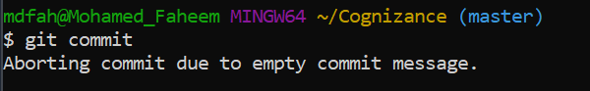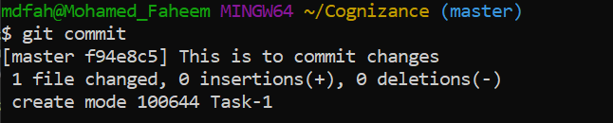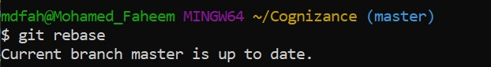

Config –list –show-origin :

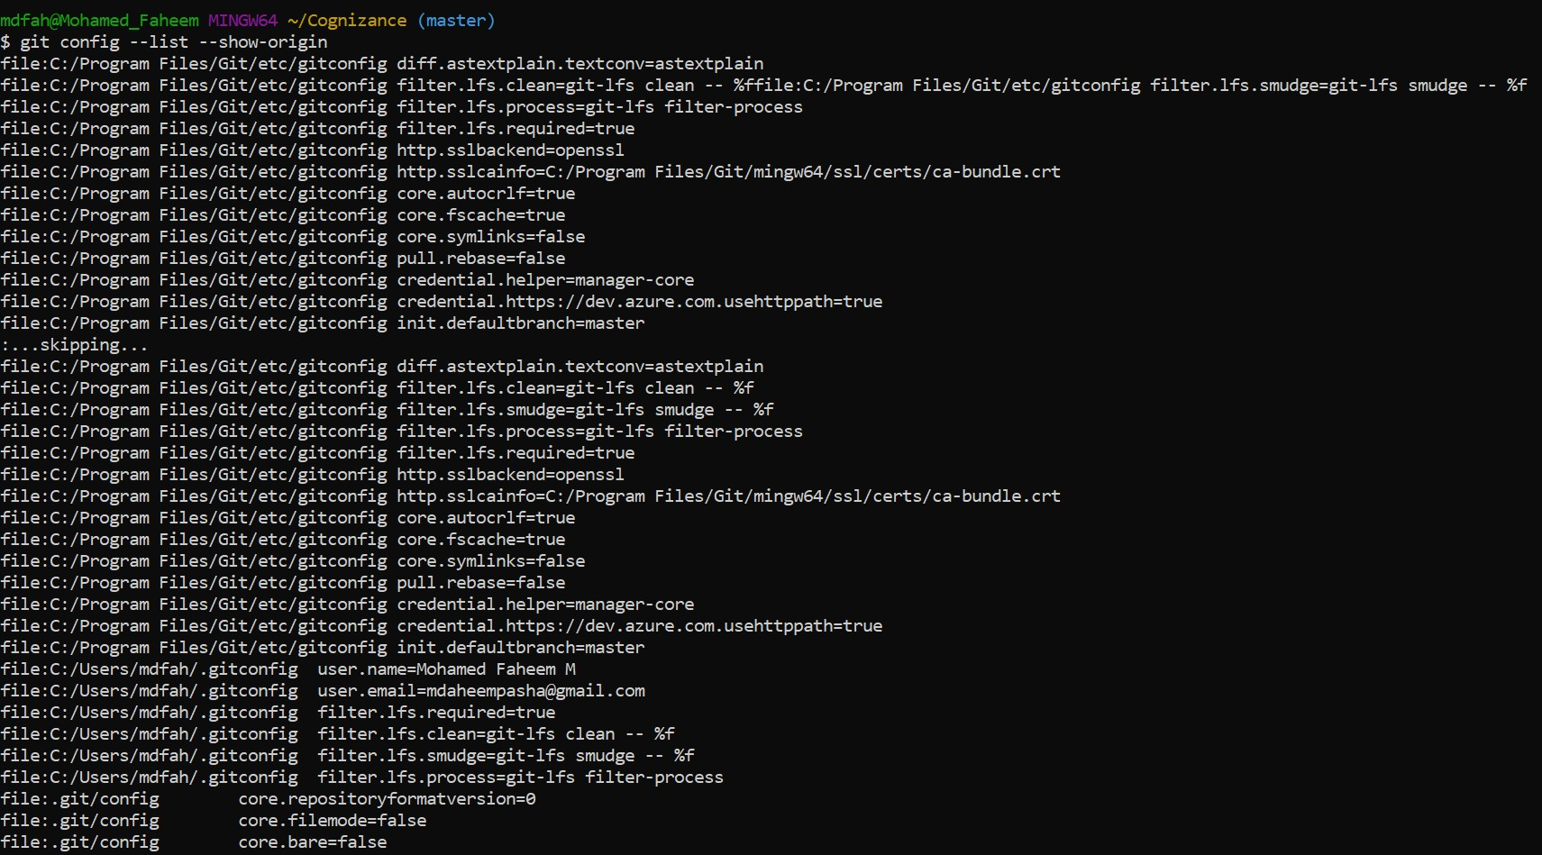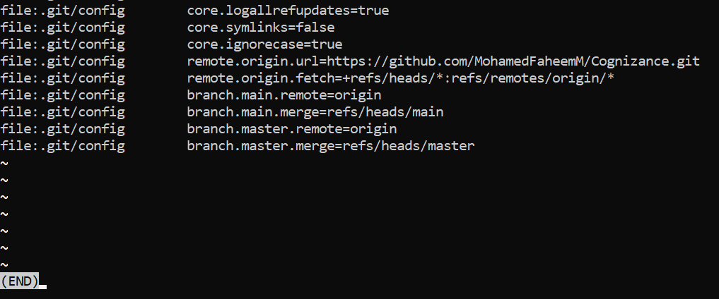

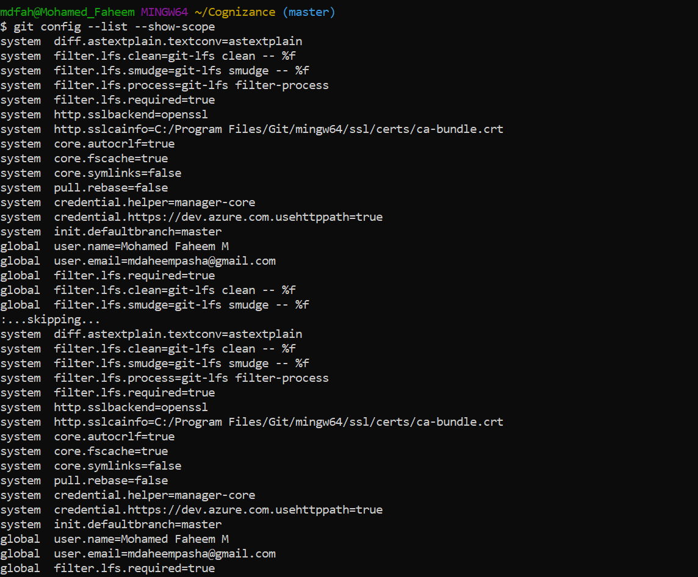

Config –list –show-scope

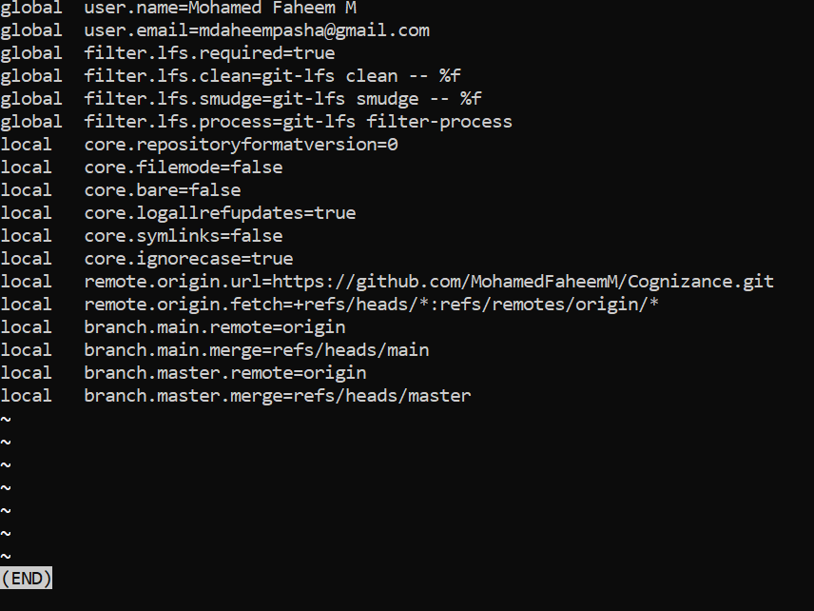

git fork

